**Question 1**

Find a program on the Internet that implements the method of Otsu and use it to compute the segmentation threshold(s) for the 400x293 B/W image of Lena stasjon. Show the resulting binary-segmented image by coloring the foreground red and the background green.

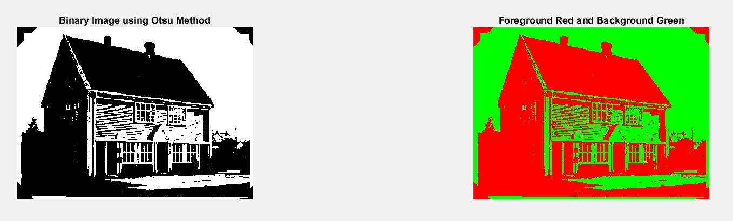

Figure 1.1 (Left) is the original binary segmented image, Figure1.2 (Right) is the binary segmented image by coloring the foreground red and background green.

**Question 2**

As an improvement to Otsu’s method, the search range for the optimal threshold can be modified using the method of Rosen. In image segmentation, specific algorithms can be designed according to the prior knowledge of the background to enhance the quality of the segmentation. Show the resulting binary-segmented image for the black and white photo of Lena stasjon by coloring the foreground red and the background green. Compare and discuss with the results in #1.

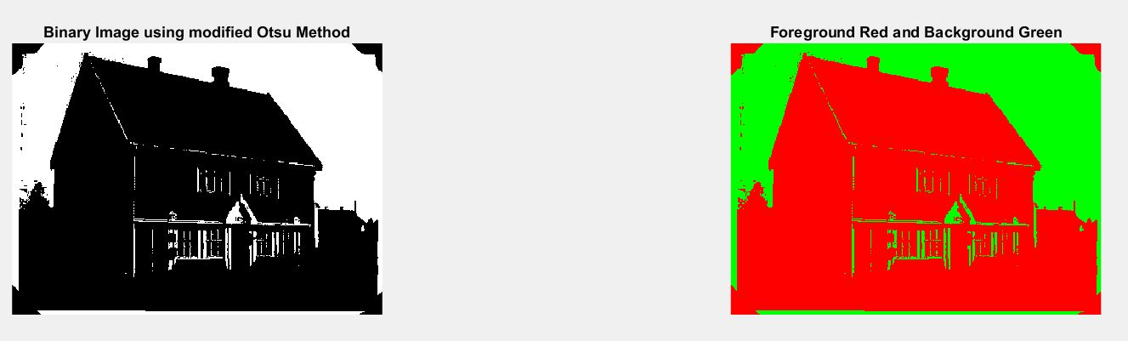

Figure 2.1 (Left) is the binary segmented image, Figure1.2 (Right) is the binary segmented image by coloring the foreground red and background green.

The objective of foreground and background separation is to clearly indicate the foreground and background and label each one with different color, therefore the modified Otsu method performs better. As shown in Figure 2.2, most part of the house including the walls is colored by red as the foreground. On contrast, some windows and walls in Figure 1.2 are incorrectly being labeled as green color as the background. This result makes sense duet to different threshold value used. The threshold in Figure 1.2 is 133 (0.5176 after normalization), whereas the threshold in Figure 2.2 is 181 (0.7059 after normalization). Many pixels of walls and windows are 133 between 181, which got ignored and labeled as the background by using the original Otsu method. These pixels, however, are included by using the modified Otsu method as the foreground because the higher threshold value used.

**Question 3**

Compute and plot the three individual 1D histograms for each of R, G, and B in the whole RGB color image Lena stasjon. Comment on what information can be discerned from the images by an examination of the three histograms.

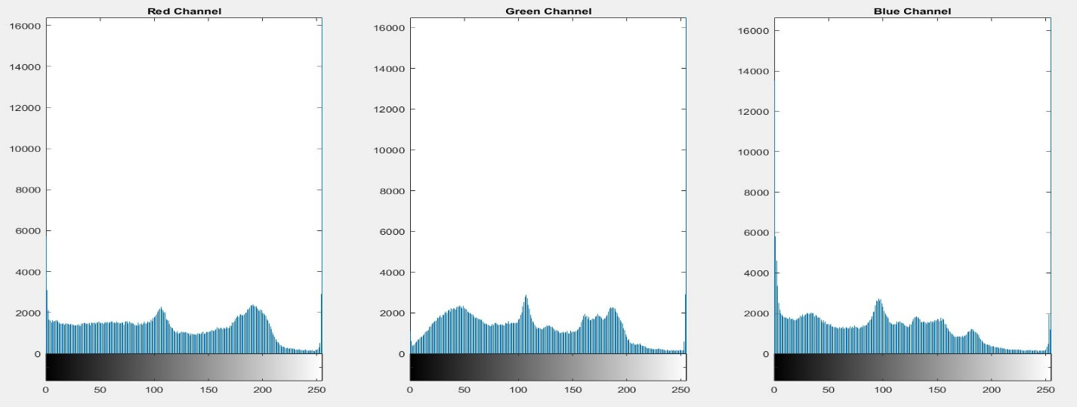

Figure 3.1 1D histogram for R (left), Figure 3.2 1D histogram for G (Middle), Figure 3.3 1D histogram for B (Right)

Overall, this is a relatively high contrast image because the pixels are distributed evenly in three channels. Further, each histogram has a very high peak around the value of 255, because of the white sky in the background, and the milky walls of the house. The color white consists of pixels with 255 equally from three channels. Also, the number of pixels between 200 and 250 is the fewest (nearly flat), because there are not other places using any colors similar to the white except the sky and walls. Besides, histograms have a common peak at around 100 due to the house roof, which is dark red or brown.

In detail, there are two peaks in the red channel because of the house roof. Similarly, there are three peaks in the green channel, which are around 50, 100 and 180. These refer to the trees with different shades around the house. In the blue channel, there is a huge peak around 0. This is reasonable because there are not many blue color objects in the picture.

One thing to notice that the RGB histograms only tell the information about the number of pixels with different values ranging from 0 to 255. However, it ignores the spatial information such as the object shape and its texture.